Group Report
Introduction
This report will explain and analyse the design process of the project our group has undertaken. The project we have collectively chosen is Project 1: Command-Line Inventory Management System. Our group must create a command-line application to help a small business owner track product inventory.

We consist of 6 members including Tolulope Akinrinlola, Charlie Millington, Erin Rayworth, Harrison Bonney, Haillie Tiger Lyons, and Rhys Jones. Our team has equally allocated roles and each member will contribute equally to all or most aspects of the project.

This report will consist of multiple sub-sections consisting of:
==========================================================================
System Design
Explain the design process and illustrate the main logic of our application, describing both the data structures and file formats.
==========================================================================
Implementation Summary
This section will discuss key implementation details and technical decisions that have been made by our team to better the project. Any unexpected or significant challenges that were encountered will also be highlighted, outlining both the problems we were troubled with and the solutions we devised to deal with these problems.
==========================================================================
Testing
A comprehensive test plan that provides clear and concise evidence of testing that was carried out by our team. The test plan consists of the inputs used and the resulting outputs, The predicted output vs the actual output we were met with, along with screenshots that clearly evidence these tests.
Feature | Test description | Test steps | Expected result | Actual result | Pass/fail | Comment on fix
First time running | Running the program for the first time to see if it works | Run  Main menu displays | The program runs without any errors and works correctly | The program runs and the main menu is displayed | Pass | N/A
Testing add item function | Selecting the add item feature | Run the program  Press 1 to access function | That the program runs and add item works | The function works | pass | N/A
Testing adding an item | Entering item to add to the function | User enters item, price and quantity | The program adds the item and all data to the json file | An error happens  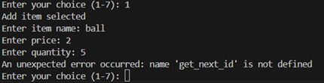 | Fail | Add get_next_item function  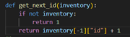
Testing adding item again | Enter item to the add function | User enters item, price and quantity | The program adds the item and all data to the json file | It runs correctly | pass | N/A
Check if item is added to json | Enter item to the add function | User enters item, price and quantity | The program adds the item and all data to the json file | The item isn’t added to the file | fail | Fix function to add item  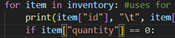  Stock had to be changed to quantity in view_stock and update_item
Check if item is added to json | Enter item to the add function | User enters item, price and quantity then press 5 to save item | The program adds the item and all data to the json file | The data is added to the file | pass | N/A
Testing view stock | Enter menu option to display items and their stock | Press 2 on main menu | The stock and items names are displayed | The stock and item names are displayed  But so is the total amount of all stock added which isn’t needed | pass | Delete total stock from the function
Testing view stock | Enter menu option to display items and their stock | Press 2 on main menu | The stock and items names are displayed and no total stock | The stock and item names are displayed  Total stock isn’t displayed | pass | N/A
Test update item | Enter menu option 3 to update the stock | Press 3 on main menu then enter product id, price update and stock amount then press 5 to save | The product id entered should be found, price should then be updated based on amount entered, same with stock. | The items are updated after save is pressed | pass | N/A
Test select item | Enter menu option to search through list | Enter 4 on the menu | The program should go through the search function | The function loads correctly | pass | N/A
Test input on search | Enter item wanting to be searched | User enters input | The program should accept input if correct and display item details | The function works correctly | pass | N/A
Test input on search | Enter item wanting to be searched | User enters input | The program should accept input if correct and display item details | The function works correctly | pass | N/A
Test main menu | Check user input is valid and not outside the allowed options | Test negative input isn’t accepted | The program should return an error and ask user to input again | The error is returned | pass | N/A
Test main menu | Check user input is valid and not outside the allowed options | Test input above 7 | The program should return an error and ask user to input again | The error is returned | pass | N/A
Checking price input | Check user can only enter an integer or float | Test a string input | The program should return an error | An error is returned saying invalid input, but program then returns to main menu instead of asking again | pass | Change so program loops back to ask user again  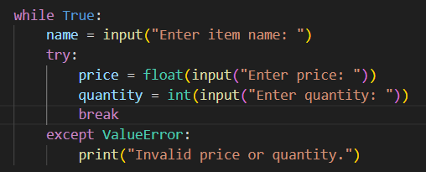  Add while loop to fix
Checking price input | Check if user input invalid price and loops to ask question again if users’ input is incorrect | Test string input | The program should return an error and then ask again. | It works and asks user to input item again. | pass
Check stock number input

==========================================================================
Contributions
This section provides a constructive breakdown of the contributions made by each member of our team delivered in list format. This allows fairness during the project ensuring all members of the project make valid and useful contributions.
==========================================================================
Reflection
This area of the report is a reflective analysis of the teamwork of our team and how teamwork contributed to the better completion of the project. It will also discuss the positives and negatives of what went well and what went wrong with the processes and decisions made, taking into consideration what could have been done differently. What can be done differently next time and reflect on how we as a team managed the collaboration.
==========================================================================

==========================================================================
Conclusion
Finally, the conclusion of this report summarises the project as a whole, outlining and discussing both the stepping stones and the achievements that have been made during the life of the project that resulted in its completion.
==========================================================================

System Design

Implementation Summary

Testing

Contributions

Reflection

Conclusion

